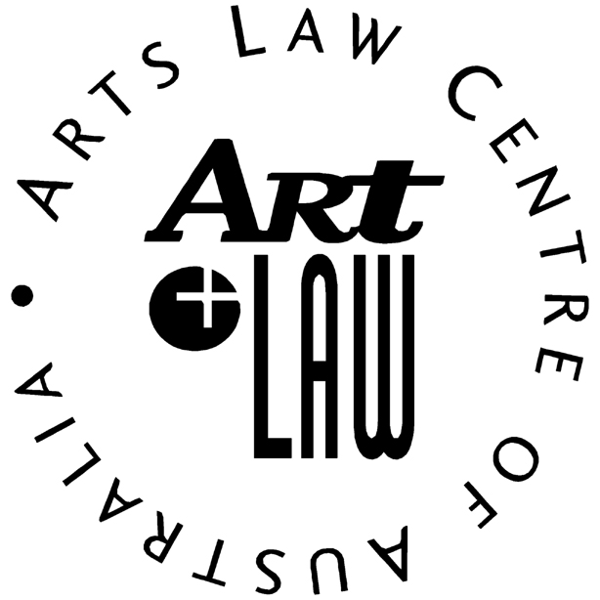
The ARTS Community Pro Bono Award nomination form
Organisation Information
Name of organisation nominating the pro bono lawyer:

Name of person nominating the pro bono lawyer:

Contact details for the person nominating the pro bono lawyer
Phone: |  | Email:
Address:
City: | State: |  | Postcode:
PRO Bono Lawyer Information
Name of the pro bono lawyer who is being nominated for ‘The Arts Community Pro Bono Award’:

Contact details of the pro bono lawyer who is being nominated for ‘The Arts Community Pro Bono Award’
Phone: |  | E-mail:
Address:
City: | State: |  | Post Code:
Please write 200 words or less about why the lawyer you are nominating should win ‘The Arts Community Pro Bono Award’:
Please return completed form to artslaw@artslaw.com.au by Friday the 16th of May 2014.

